**Different Types of Distribution:**

1. **Normal Distribution (Gaussian Distribution):**
2. **Binomial Distribution:**
3. **Poisson Distribution:**
4. **Uniform Distribution:**
5. **Exponential Distribution:**
6. **Log-Normal Distribution:**
7. **Gamma Distribution:**

**Normal distribution (Gaussian Distribution):**

A normal distribution, also known as a Gaussian distribution, is a continuous probability distribution that is characterized by its **symmetric bell-shaped curve**. It is one of the most common and important probability distributions in statistics and probability theory. The normal distribution is often used to model real-world phenomena, as many natural processes tend to exhibit approximately normal behaviour.

The normal distribution is defined by two parameters: the mean (μ) and the standard deviation (σ). The mean represents the centre of the distribution, and the standard deviation determines the spread or dispersion of the data around the mean.

**Empirical Rule of Normal Distribution:**

The Empirical Rule states

* 68% of the data falls within one standard deviation,
* 95% percent within two standard deviations
* and 99.7% within three standard deviations from the mean.

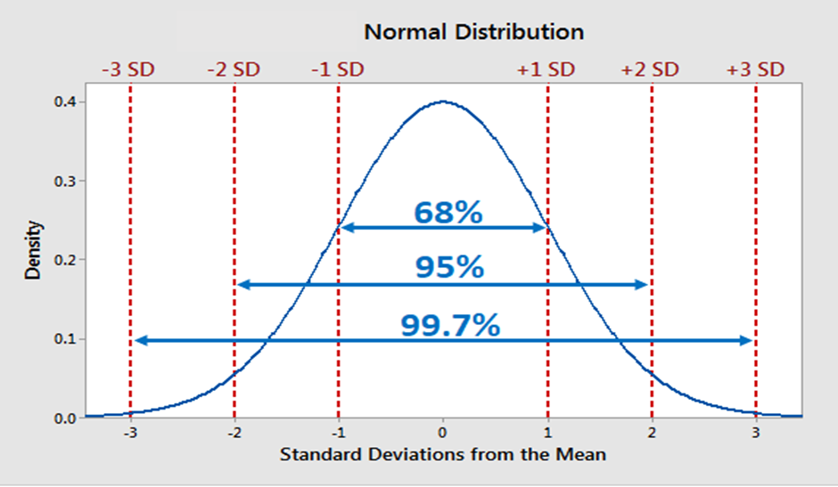

* The normal distribution is the proper term for a probability bell curve.
* In a normal distribution the mean is zero and the standard deviation is 1. It has zero skew and a kurtosis of 3.
* Normal distributions are symmetrical, but not all symmetrical distributions are normal.

**Uniform Distribution:**

A distribution where all outcomes are equally likely. It is characterized by a constant probability density function over a specified range.

**Binomial Distribution:**

Describes the number of successes in a fixed number of independent trials, each with the same probability of success, making it applicable in scenarios involving binary outcomes like success or failure.

**Poisson Distribution:**

Models the probability of a given number of events occurring in a fixed interval of time or space, particularly useful for rare events where occurrences are random and independent.

**Exponential Distribution:**

Models the time between events in a Poisson process, where events occur continuously and independently at a constant average rate, making it applicable in scenarios such as waiting times and survival analysis.

**Log-Normal Distribution:**

The logarithm of the variable follows a normal distribution, often seen in data where values are naturally positive and skewed; it's used in financial modelling, biology, and other fields.

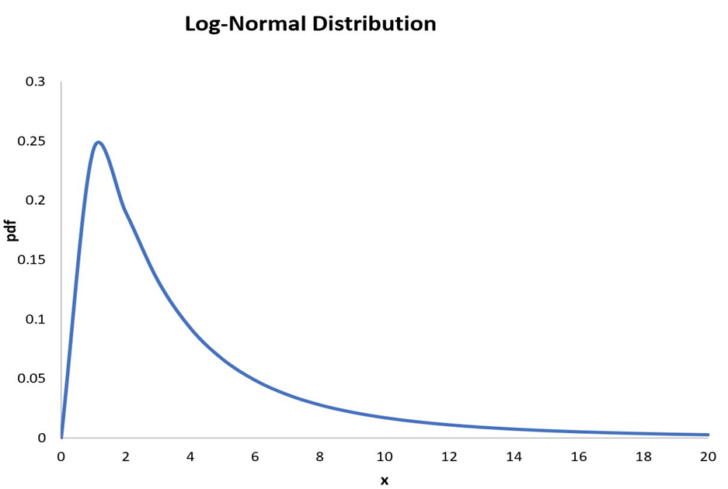

In probability theory, a log-normal (or lognormal) distribution is a continuous probability distribution of a random variable whose logarithm is normally distributed. Thus, if the random variable X is log-normally distributed, then Y = ln(X) has a normal distribution. Equivalently, if Y has a normal distribution, then the exponential function of Y,  
 X = exp(Y), has a log-normal distribution.

**Gamma Distribution:**

Generalizes the exponential distribution, often used to model the time until a specified number of events occur in a Poisson process or for continuous non-negative variables with skewed distributions.